Introduction & Background:
Traffic congestion brings steep costs in fatalities and pollution [1]. In response, NYC’s Metropolitan Transportation Authority (MTA) introduced a Congestion Relief Zone (CRZ) in January of this year, requiring tolls on vehicles entering the area [2]. Given the recency of the zone’s creation, most studies on its effects come from the MTA itself. For example, the MTA found lower levels of air pollution post implementation [3].
We are interested in using forecasting to analyze the efficacy of the CRZ, accounting for interactions between vehicle traffic and NYC public transit. According to an MTA survey, subway delays necessitate riders finding alternative means of transportation, most frequently taxis [4].

Dataset
Traffic Dataset: Maintained by the MTA and begins with the CRZ’s launch. Each row corresponds to a 10-minute interval of a particular day. Features include vehicle counts, toll period (rate), vehicle type, entry detection point, and region of origin.
NYC Subway Dataset: Details daily operations since 2021, including trip metadata (e.g., route, direction, start time, vehicle, schedule changes, etc.) and stop-level details (e.g., track assignments, arrivals, departures, etc.).

Literature Review
Traffic forecasting models can consider time (e.g., rush hours) and/or space dependencies (e.g., interconnected roads). Classic methods like ARIMA and deep learning methods like LSTMs model only time, while spatiotemporal ARIMA, CNNs that treat traffic as image grids, and GNNs that treat roads as graphs also account for space [5].

Problem Definition:
Urban congestion in NYC persists despite the CRZ [6]. Public reporting quantifies traffic outcomes but rarely models, at fine temporal granularity, how subway delays propagate to vehicle inflows. A robust short-term forecasting system for the CRZ integrating traffic-transit correlations could support adaptive tolling strategies to both reduce emissions and ensure fair pricing.

Methods:

Data Preprocessing
Temporal alignment: Given the massive volume (100M+ rows) of data in both sources, we limited the subway dataset to trip-level records (since stop-level data will propagate) and cropped the data to the period from August 1st through October 5th of this year.
Because the MTA traffic dataset is reported in 10-minute intervals, the subway data was similarly aggregated. Specifically, all time fields in the subway dataset (including departures and last-seen times) were converted from Unix epochs to standard timestamps and then rounded down to the nearest 10-minute mark. The subway and traffic datasets were subsequently joined on corresponding 10-minute intervals.
Missing data: Since fewer than 2% of all rows (i.e., trips) in the subway dataset contained null values in any column, those rows were dropped.
Feature engineering: To analyze subway delays, we needed to establish baseline end times. Within each group of subway trips associated with a specific route, direction, and time of day (e.g., all northbound 7-line trips starting between 8:00AM – 8:10AM), the average last-seen time (i.e., the last recorded timestamp for the train) was calculated.
Then, for each individual trip recorded in the subway dataset, we calculated how much its actual last-seen time deviated from the baseline last-seen time for its route-direction-time group. A new feature (‘avg_delay,’ in minutes) was created with the average of these deviations across all trips operating in a 10-minute datetime interval (e.g., all trains running from 8:00AM – 8:10AM on 8/01). We also created a ‘total_trips’ feature capturing how many trips were in service during that window.
Additionally, to set the dataset up as a supervised time series regression task, we created a new feature with a rolling mean of the number of CRZ entries of the same vehicle class and detection region over the previous three intervals for each row. The same was done for excluded roadway entries (i.e., number of CRZ entries through roads exempt from tolls). These rolling features smooth short-term fluctuations while allowing the model to learn temporal patterns [7]. Note that these rolling features are only used by the supervised models.
Encoding: In the subway data, {route, direction} pairs were one-hot encoded into 60 binary features like ‘route_H_1.’ These are not mutually exclusive, meaning multiple routes (or none) may be active during the same interval. In the traffic data, we one-hot encoded the time period (overnight or peak), day of the week, vehicle class (car, single unit truck, multi unit truck, bus, motorcycle, or taxi), and 7 CRZ detection regions.
Each row in the joined dataset corresponds to a particular vehicle class at a particular detection region during a particular 10-minute interval. For example, in the 8:00AM - 8:10AM interval on 8/01, one row may represent car entries through Brooklyn, another row may represent truck entries through New Jersey, and so on across all applicable vehicle classes and regions.
Summary: The final dataset was ~393k rows and 88 columns, including 4 continuous variables (the rolling means, the average subway delay, the total subway trips) and 2 target variables (regular entries and excluded roadway entries).
A note on scaling/normalization: While the proposal stated we would normalize continuous features using scikit-learn StandardScaler or MinMaxScaler, this was not required because the unsupervised dimensionality reduction method we used performs internal normalization, and our supervised models are tree-based methods which are inherently scale-invariant [8, 9]. We explain further in the following sections.

Unsupervised Algorithms

Dimensionality Reduction:
Algorithm: While the proposal mentioned sklearn.preprocessing.PCA or umap-learn.umap to capture the most significant sources of variation in traffic congestion, these algorithms are designed to work with continuous features [10]. We have 81 categorical features and only 2 continuous features for the unsupervised tasks. To handle mixed types, we opted for Factor Analysis of Mixed Data (prince.FAMD), which combines PCA for continuous variables with MCA (multiple correspondence analysis) for categorical variables. FAMD also automatically standardizes numeric variables [11].
The Random Forest and XGBoost models we implemented do not require normalization or feature reduction [8, 9]. The FAMD model was implemented to use with our HDBSCAN clustering model, which is better suited to high dimensionality than other density-based algorithms, but still significantly benefits from feature reduction [12].
Data preparation: The FAMD reduced dataset is provided as input to the clustering model. Importantly, to prevent data leakage from allowing the unsupervised models to see the global structure of the data, the dataset was chronologically split into training (30%), validation (15%), and test (15%) sets before any reduction. The FAMD model was fitted to the training set, then used to separately transform validation and test sets.
Tuning: Since FAMD only takes a number of components as input (as opposed to PCA, which accepts a percent variance), we added an n_components factor to our grid search function for the clustering model parameters, as explained in the next section.

Clustering:
Algorithm: We wanted to group time intervals with similar traffic and transit characteristics to identify recurring patterns and isolate anomalies (e.g., sudden traffic surges linked to major subway disruptions). We identified three options to do so in the proposal: sklearn.cluster.KMeans, sklearn.cluster.DBSCAN, and hdbscan.HDBSCAN [13, 14]. After data cleaning, we decided to pursue HDBSCAN given our high dimensional, mostly sparse feature space and the likelihood that clusters of interest would have uneven density across different days, times, regions, and routes.
Hierarchical Density-Based Clustering is an extension of DBSCAN that identifies clusters of varying density by building a hierarchy of potential clusters and selecting the most stable ones, rather than requiring a single global density threshold [12].
Data preparation: Similar to the FAMD model, the HDBSCAN model is fitted to the reduced training set. This model is then used to predict (using the hdbscan.HDBSCAN approximate_predict function) the clusters for the reduced validation and test sets.
Tuning: We used a manual grid search function on silhouette score, Davies-Bouldin Index, and noise percent over a small parameter grid to pick n_components for FAMD and min_cluster_size, min_samples for HDBSCAN simultaneously. The minimum cluster size controls the smallest group of points that should be considered a cluster, and the minimum samples controls how many neighbors a point must have to be considered part of a cluster vs. noise [12]. The previous version of the model used n_components = 10, min_cluster_size = 30, min_samples = 30, the combination from grid search which yielded the lowest Davies-Bouldin Index and highest silhouette score. However, this version identified only four clusters, with 99% of the training set being assigned to a single cluster.
To capture more granular or event-specific behavior (e.g., subway disruptions) as opposed to very broad patterns (e.g., standard rush hours), the current version uses n_components = 8, min_cluster_size = 30, min_samples = 20, which produces a more even distribution with relatively low noise at the cost of a slightly higher DBI and lower silhouette score.
HDBSCAN also accepts the distance metric and cluster selection method as a parameter. We opted to go with the standard/recommended combination of the Euclidean distance metric and Excess of Mass (‘eom’) cluster selection (i.e., choose the final set of clusters from the hierarchy by prioritizing stable, well-separated clusters) [12].

Supervised Algorithms

Random Forest Regression:
Algorithm: The proposal described using sklearn.ensemble.RandomForestRegressor as a strong baseline that can capture short-term dependencies and nonlinear interactions [15]. At a high level, Random Forest Regression is a tree-based ensemble model that combines predictions across many randomly constructed decision trees to produce a single, averaged output (here, a number of vehicles) for each data point [16].
Note that a GPU-accelerated version of the Random Forest package (cuml.ensemble.RandomForestRegressor) was used, wrapped in a sklearn.multioutput.MultiOutputRegressor to handle the two target variables.
Data preparation: A benefit of the Random Forest model is that it requires little data preparation [8, 9]. We simply added the computed rolling mean features back into the dataset, as well as a feature for the generated cluster labels. The train, validation, and test sets split before FAMD were carried over. Again, the regression model was fitted to the training set and then used to predict outputs for the validation and test sets.
Tuning: We used sklearn.model_selection.RandomizedSearchCV to randomly sample combinations from a parameter grid of 2592 combinations and evaluate each configuration using cross-validation on the R^2 score [17]. The Random Forest Regressor model has parameters n_estimators (number of trees in the forest), max_depth (maximum depth of each individual tree), min_samples_split (minimum number of samples required to split a node), min_samples_leaf (minimum number of samples required in a leaf node), and max_features (number of features considered when choosing each split) [16]. The best set of parameters found was n_estimators = 200, min_samples_split = 10, min_samples_leaf = 1, max_features = 0.3, max_depth = 20.
Note that we used sklearn.model_selection.TimeSeriesSplit with n_splits = 3 to create the cross validation splits without introducing data leakage.

XGBoost Regression:
Algorithm: We planned to compare the Random Forest model to an xgboost.XGBregressor, which iteratively minimizes errors [15]. XGBoost is another tree-based ensemble model. Specifically, it is a gradient-boosted decision-tree model that constructs many trees in sequence, where each tree is trained to reduce the errors of the earlier trees, and sums their outputs into a final prediction [18].

We wrapped the model in a `sklearn.multioutput.MultiOutputRegressor` to handle the two target variables again.

Data preparation: Since XGBoost does not require normalization or feature reduction either, this step was identical to the Random Forest model [8, 9]. Rolling means and cluster labels were simply added as features to the previously split train, validation, and test sets.

Tuning: As with the Random Forest model, we used sklearn.model_selection.RandomizedSearchCV to randomly sample combinations from a parameter grid of 1296 combinations and evaluate each configuration using cross-validation on the R^2 score [17]. We used sklearn.model_selection.TimeSeriesSplit with n_splits = 3 to create the cross validation splits again.

The XGB Regressor model has parameters subsample (fraction of training rows sampled for each tree), reg_lambda (L2 regularization term on leaf weights), n_estimators (number of trees/boosting rounds), max_depth (maximum depth of each tree), learning_rate (shrinkage step size controlling how much each tree contributes to the prediction), and colsample_bytree (fraction of features sampled for each tree) [18]. The best set of parameters found was subsample = 1.0, reg_lambda = 1.0, n_estimators = 600, max_depth = 4, learning_rate = 0.1, colsample_bytree = 1.0.

Results & Discussion
Our goal is to develop a system that can forecast traffic inflows into the CRZ in 10-minute intervals, with consideration for subway trends and/or disruptions.

Clustering:
Metrics: The current version of the HDBSCAN clustering model achieves a silhouette score of 0.349, a Davies-Bouldin Index of 0.9145, and 27% noise, with 3,138 clusters total. The previous version achieved a silhouette score of 0.414, a Davies-Bouldin index of 0.4326, and 0% noise, with 4 clusters total. However, as previously mentioned, the drop in the silhouette score and rise in the DBI was intentional, to get a more even detailed and generalizable clustering structure.
The figures below summarize the new cluster distributions for the train, validation, and test sets:
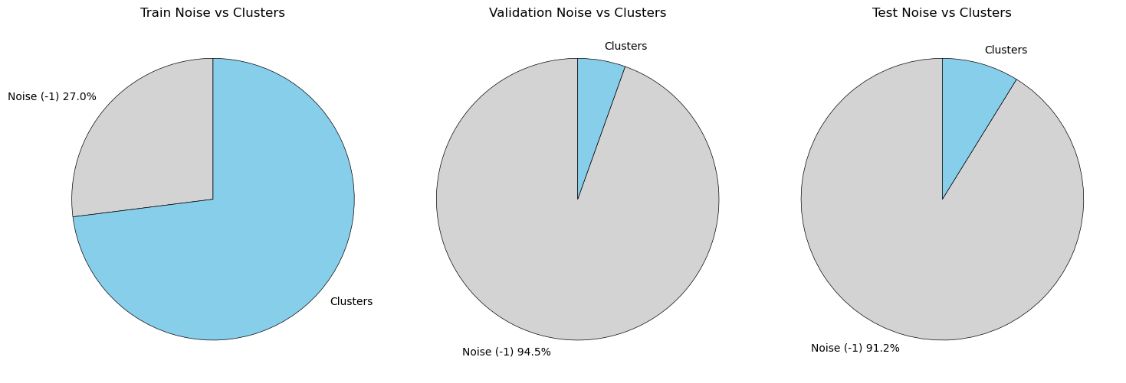
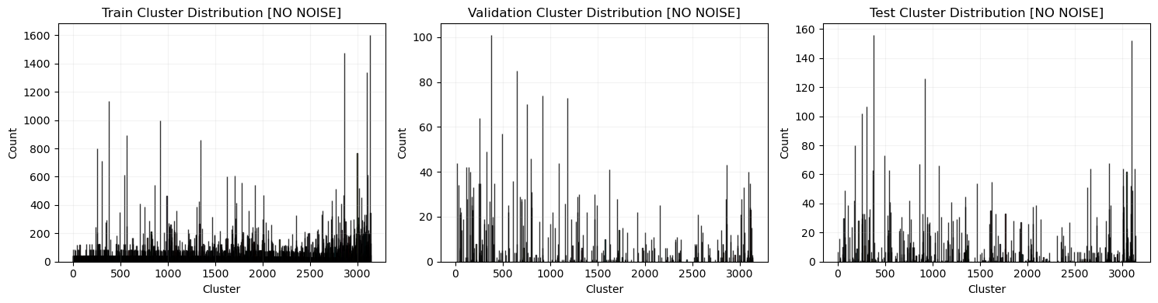

The new clusters are plotted (using PCA) for the training set below:
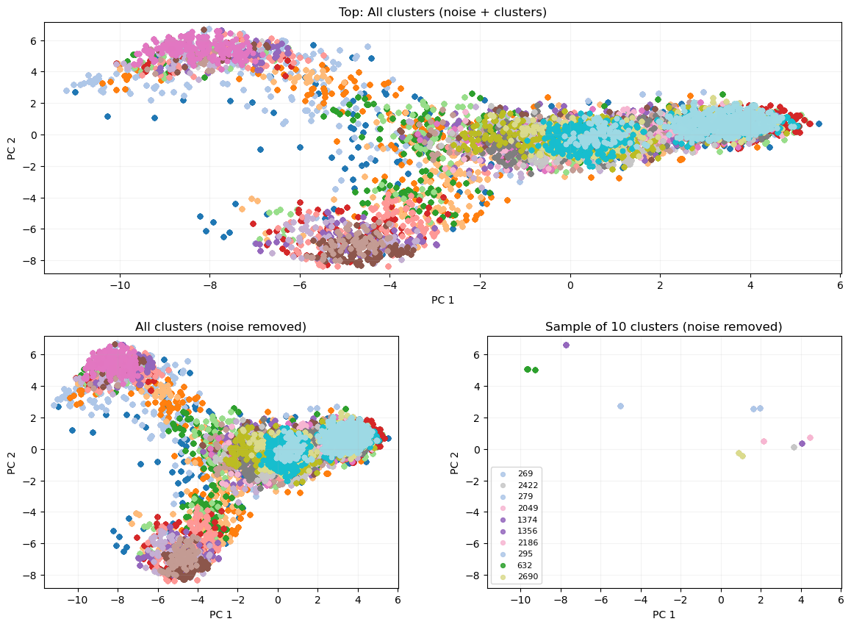
For reference, the earlier cluster distributions looked like:
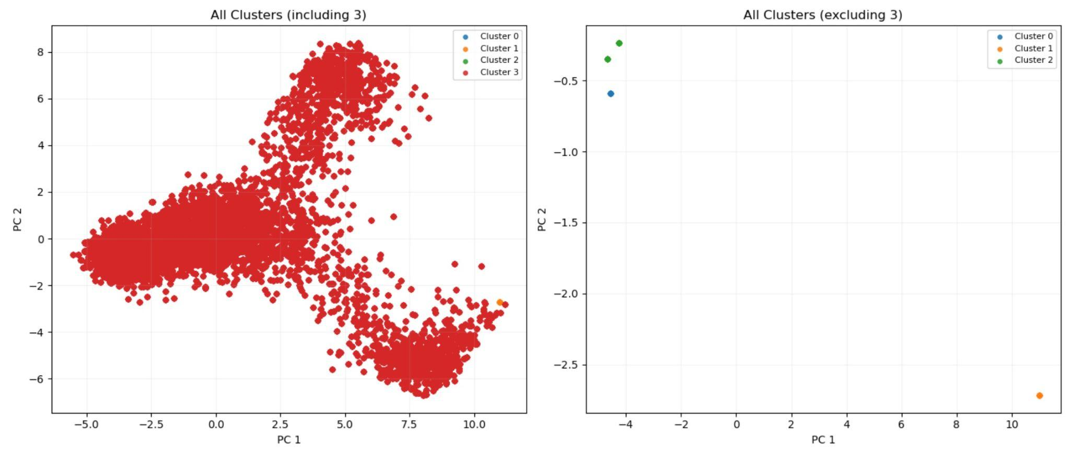

Set | Noise Points | Cluster 0 Points | Cluster 1 Points | Cluster 2 Points | Cluster 3 Points | Total Points
Training | 0 | 42 | 42 | 84 | 275,016 | 275,184
Validation | 58,968 | 0 | 0 | 0 | 0 | 58,968
Test | 58,967 | 0 | 0 | 1 | 0 | 58,968

From these results, it’s clear that the updated configuration did successfully uncover a more detailed clustering structure, which in theory, could align with irregular traffic events. While the silhouette score of 0.349 does fall below the ambitious 0.65+ target stated in the proposal, low to moderate values are not unexpected for high-dimensional, real-world data. The DBI of 0.91 is also still close to 0, so intra-cluster distances remain small compared to inter-cluster distances.
Generalizability: However, noise in the validation and test sets is still high, though at a much more ideal 90-95% rather than 100%. This suggests that the clustering structure is still not as generalizable as we had hoped. Because HDBSCAN is density-based, the generalizability issue likely arises from the validation and test datasets not occupying the same dense regions of the feature space as the training data. The three sets cover different periods of time, and traffic patterns change over time. For instance, traffic in October may look quite different than it did in August due to the weather, causing the test points to fall into empty parts of the training density. Additionally, the validation and test sets may have lower overall density because they are smaller than the training set, making it harder to meet the model’s density thresholds.
A hyperparameter combination which falls somewhere between the previous and current could help encourage more stable, medium-sized clusters. It might also be helpful to test alternative distance metrics, like Manhattan distance, which is more suitable to sparse data [19]. To make the clusters more flexible, we could also rely on the per-cluster probabilities generated by HDBSCAN, rather than the hard labels it generates. That way, validation and test points can be given a soft cluster assignment based on proximity, even if they are technically marked as noise.

Random Forest Regression:
Metrics: Both time series models were evaluated using Mean Absolute Error (MAE) and Root Mean Squared Error (RMSE), the standard metrics used with forecasting problems, as well as R^2 as a rough measure of correlation with the actual vehicle entry totals. The metrics for Random Forest, after rerunning with the new clustering labels, are presented below. Overall, the results are very strong, with minimal overfitting:
Random Forest Regressor with New Cluster Labels
 | R^2 |  | RMSE (in vehicles) |  | MAE (in vehicles)
Set | Entries | Excluded Roadway Entries | Entries | Excluded Roadway Entries | Entries | Excluded Roadway Entries
Train | 0.9961 | 0.9953 | 8.8649 | 3.0150 | 4.3039 | 0.7497
Validation | 0.9893 | 0.9848 | 14.9218 | 5.1994 | 6.8938 | 1.2143
Test | 0.9895 | 0.9857 | 15.1520 | 5.0843 | 7.0489 | 1.2293
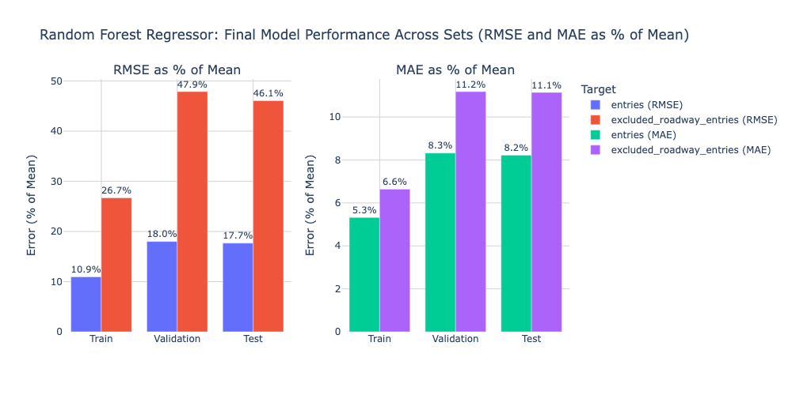
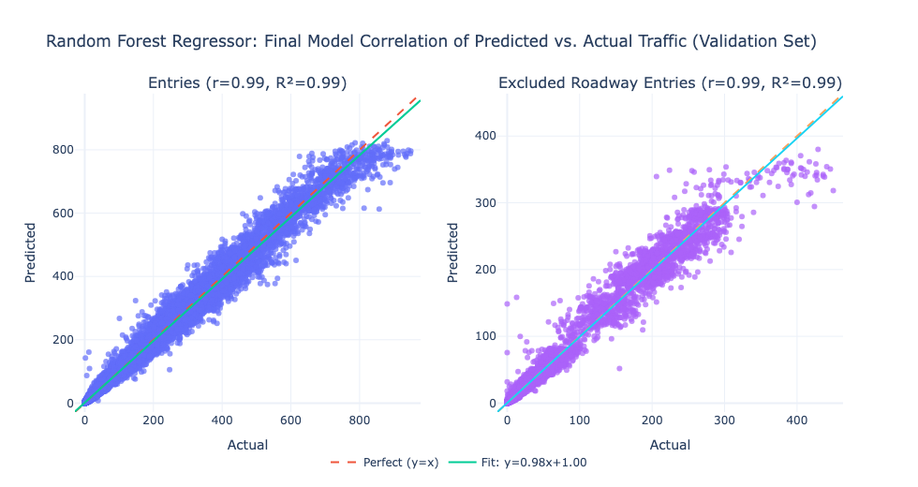
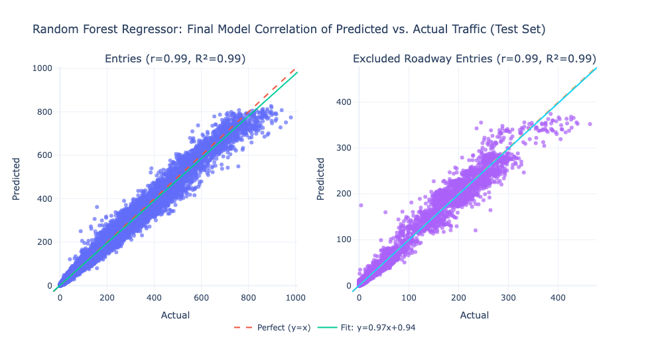
For reference, the Random Forest results with the previous clustering labels are below:
Random Forest Regressor with Old Cluster Labels
 | R^2 |  | RMSE (in vehicles) |  | MAE (in vehicles)
Set | Entries | Excluded Roadway Entries | Entries | Excluded Roadway Entries | Entries | Excluded Roadway Entries
Train | 0.9961 | 0.9952 | 8.9027 | 3.0586 | 4.3269 | 0.7583
Validation | 0.9893 | 0.9850 | 14.8544 | 5.1743 | 6.8647 | 1.2100
Test | 0.9896 | 0.9858 | 15.0487 | 5.0752 | 7.0106 | 1.2260
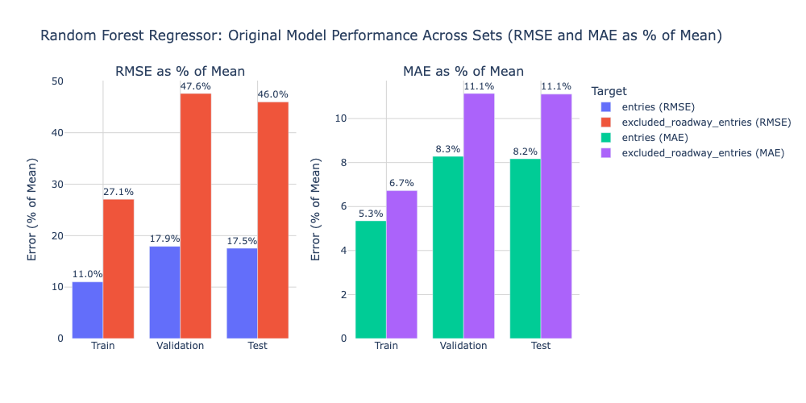
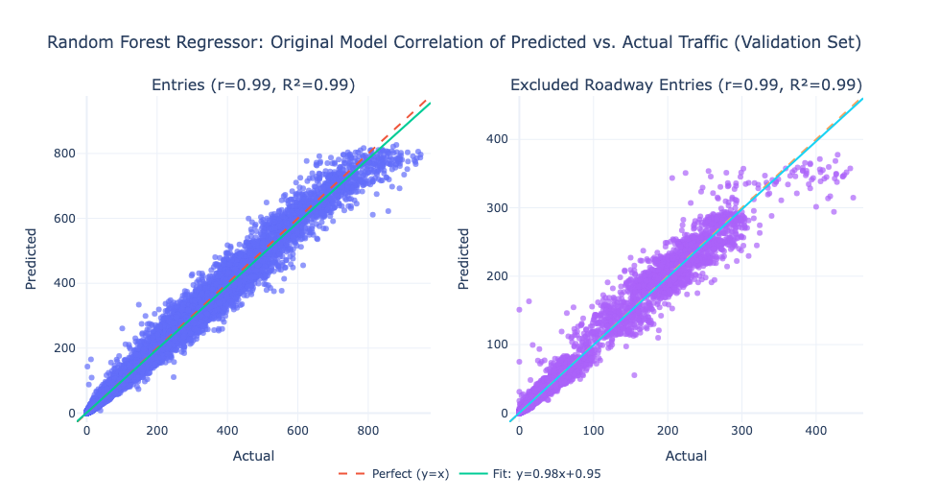
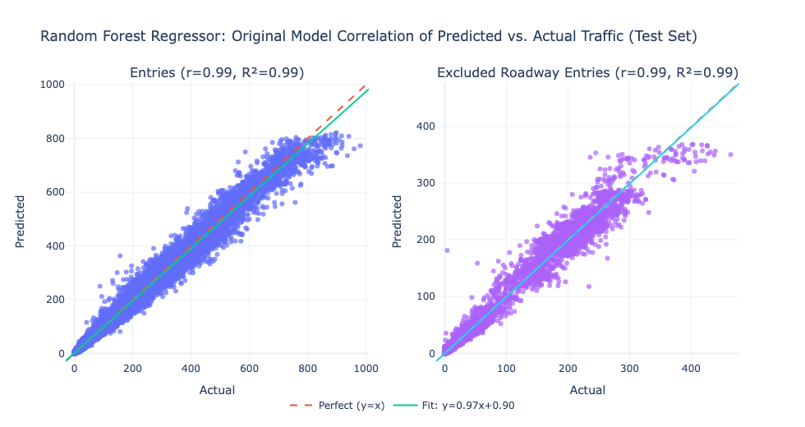
Comparing Iterations: Across all three splits and both target variables, the R^2 values under the new clustering labels are nearly identical ($±$0.0001) to those under the old clustering labels. The RMSE and MAE shift by very small margins, all within $±$0.1 vehicles for both targets. The differences are so small that we can conclude the change in clustering structure does not meaningfully impact the model’s ability to predict the target variables. The patterns captured by the clustering may be redundant with the other features, or the Random Forest model may already be robust enough that adding clusters does not translate to added accuracy.
Weights: The cluster labels also show up as a low-importance feature for both target variables:
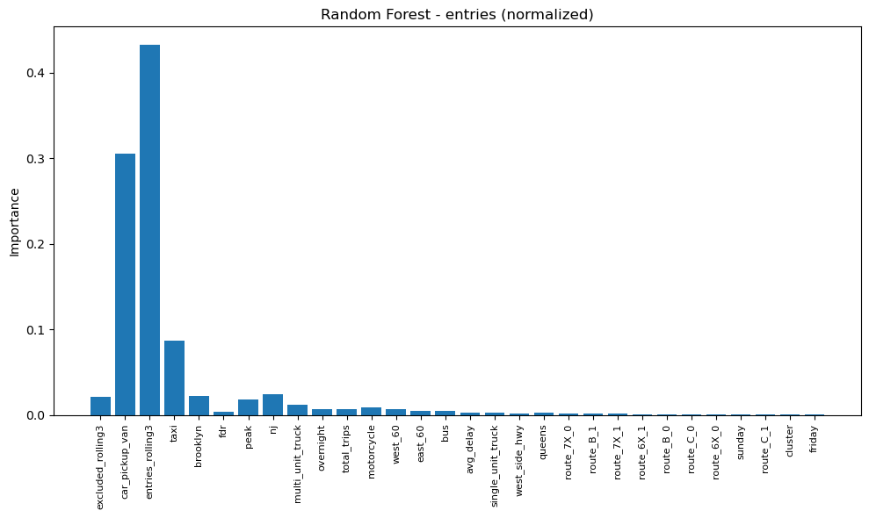
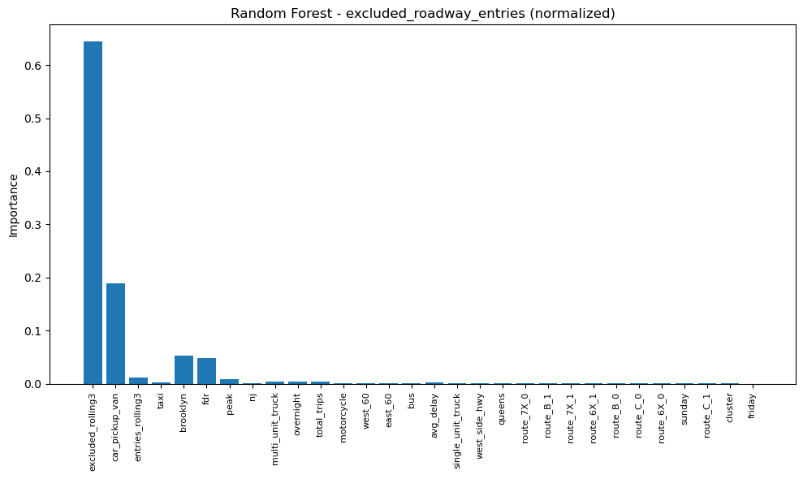
For both targets, the corresponding rolling mean is the most important feature, followed by certain roads and vehicle classes. This is expected, since the model’s objective is to forecast entry volumes based on prior intervals, and each row encodes a specific vehicle type and roadway. The differences in which roads and vehicle classes rank highest for regular entries vs. excluded entries reflect which road segments fall under the excluded category and vehicle restrictions that might apply to these roads. Variables related to tolling periods (e.g., overnight and peak hours) are also important, which is intuitive given their role in shaping driver behavior.
Notably, the subway-related total trips and average delay features also show modest importance relative to other features. Integrating additional external factors tied to traffic patterns and clustering only on these external features (e.g., subway, weather, and holiday indicators) might make the clustering step more fruitful and less redundant with the existing feature set.
(An important note on feature importances: The plotted importances reflect only the top-ranking features. Many additional subway routes, for example, have near-zero importance and are excluded for readability. In addition, since the cuML implementation of Random Forest does not support standard variance/impurity-based importance calculations, we used sklearn.inspection.permutation_importance, which measures how much worse the model performs when a single feature is randomly shuffled. The permutation importance values were then normalized between 0 and 1 before plotting.)
Overall Performance: Returning to the overall performance, while we don’t meet the original target of RMSE and MAE within 5% of average traffic volume, RMSE = ~17-18% of the mean and MAE = ~8% of the mean for entries are close and robust for real-world data, especially given that the degree of correlation between subway activity and CRZ inflow was unknown prior to modeling. Combined with the feature importances, these results suggest that subway and traffic trends in NYC are meaningfully related, and that subway trip data can support forecasting approaches for tolling policy evaluation and congestion prediction.
Performance was weaker on excluded_roadway_entries, with RMSE = ~45-47% of the mean and MAE = ~11% of the mean. However, excluded roadway entries reflect broader regional traffic behavior rather than CRZ-specific travel. The toll exemption may also prompt many drivers to actively choose these roadways, introducing strategic decision-making and variability that is not directly captured in our features. As a result, this target is inherently noisier and harder to predict, and lower performance is reasonable.
Time Plots: From the plots below, the model tends to miss more extreme points for both entries and excluded entries but captures the predictable rise-and-fall in traffic volume through the day:
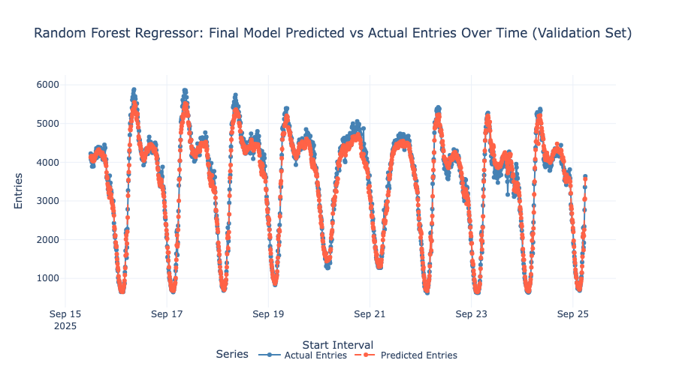
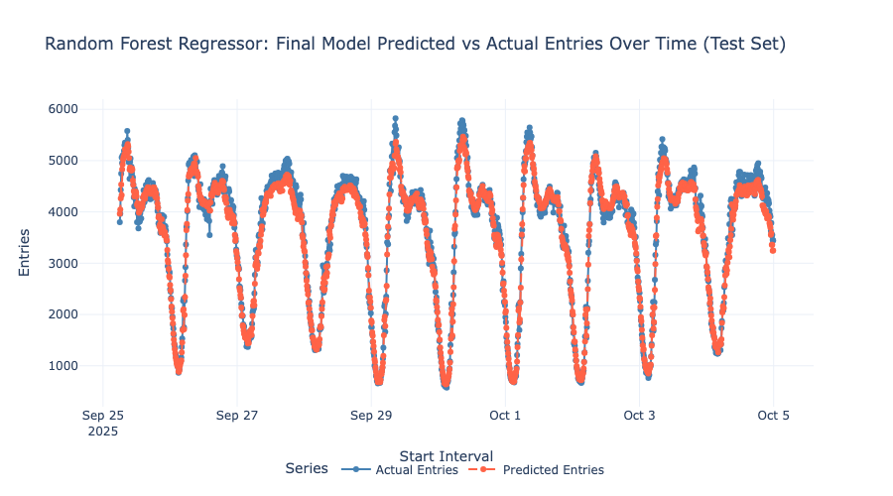
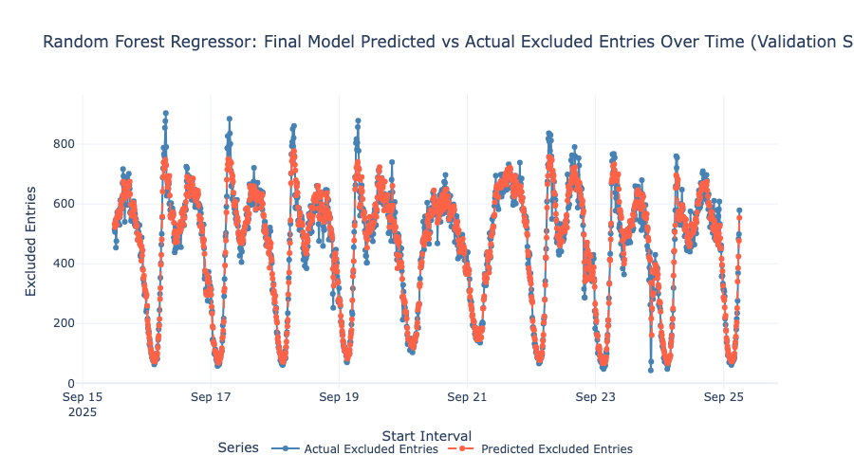
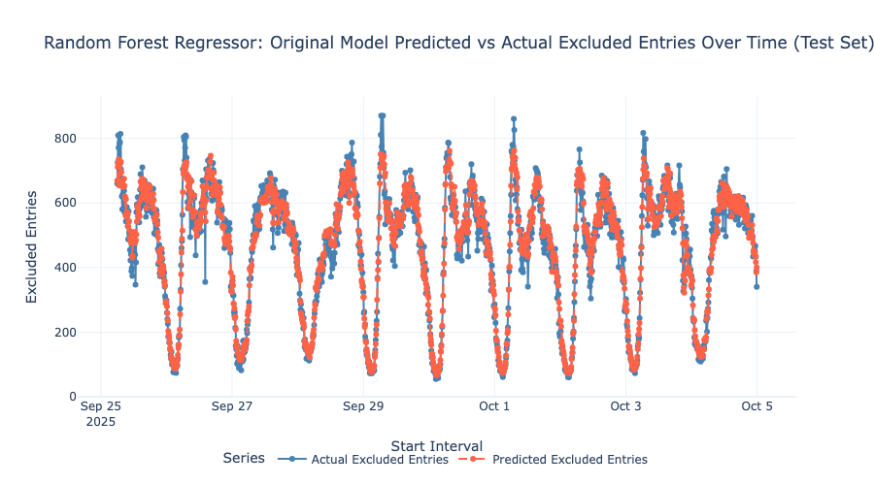
For reference, the plots from the earlier version of the model are shown below:
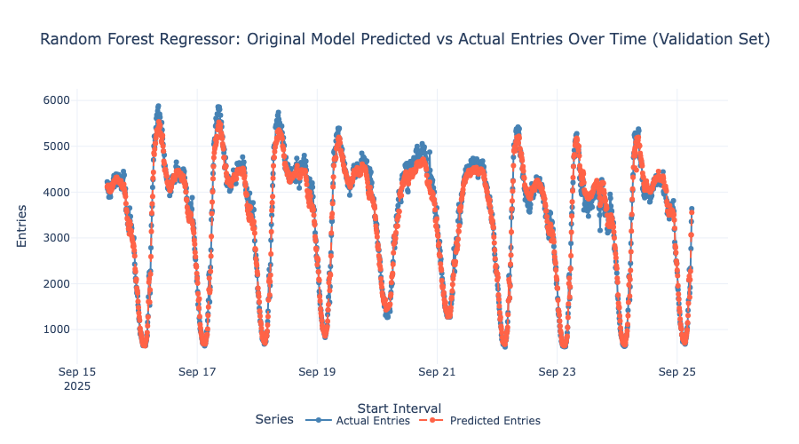
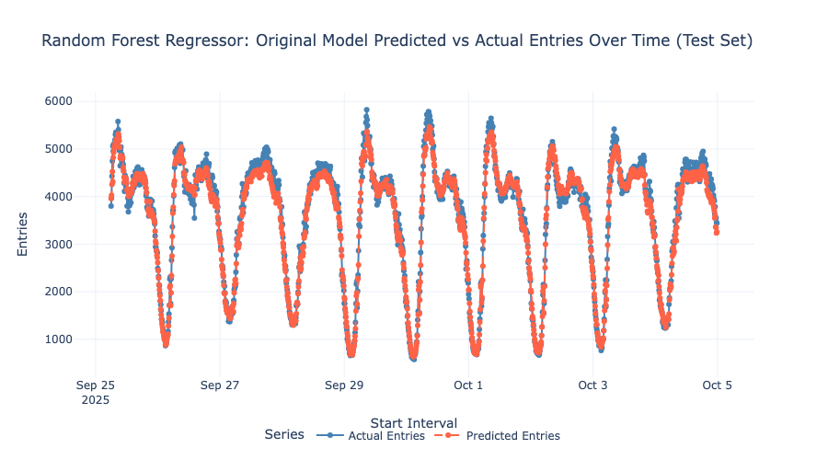
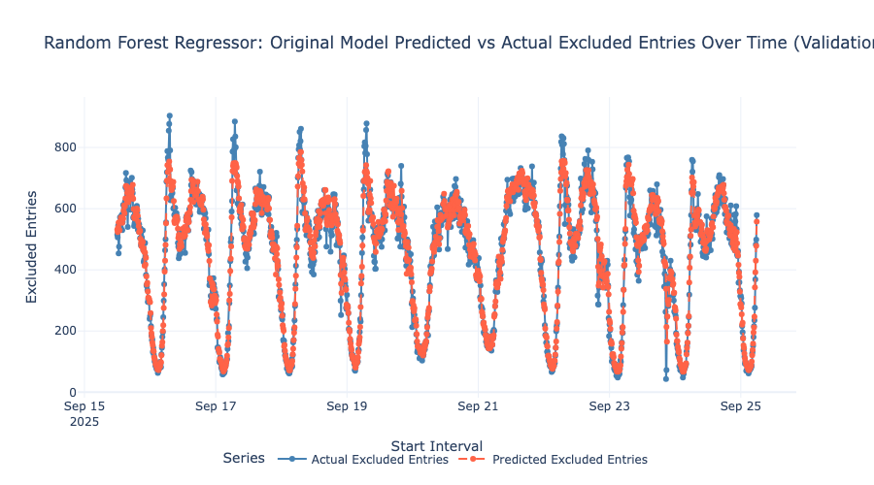

Unsurprisingly, the new plots are virtually identical to the old ones. We had previously speculated that improving the cluster structure might help differentiate the conditions leading to high or low volume points, consistent with the idea that the earlier clustering identified high-level patterns such as rush hours but missed low-level ones. However, the updated results indicate that the clustering step still does not contribute substantial signal. Beyond clustering on additional external traffic influencers, or using soft cluster probabilities to reduce noise in the validation and test sets, explicit anomaly-detection approaches may be more effective for extreme points. Methods such as Isolation Forests can help flag rare or unusual conditions that standard clustering overlooks [14]. Another direction is to make the Random Forest model itself slightly more sensitive to outliers by increasing parameters such as max_depth, min_samples_leaf, or n_estimators, though this increases the risk of overfitting.

XGBoost Regression:
Metrics: The metrics for the XGBoost model, which was run with the new clustering labels, are presented below. Again, the results are very strong, with very minimal overfitting:
 | R^2 |  | RMSE (in vehicles) |  | MAE (in vehicles)
Set | Entries | Excluded Roadway Entries | Entries | Excluded Roadway Entries | Entries | Excluded Roadway Entries
Train | 0.9959 | 0.9969 | 9.206 | 2.4369 | 4.5310 | 0.6890
Validation | 0.9932 | 0.9896 | 11.8815 | 4.3117 | 5.6649 | 1.0696
Test | 0.9934 | 0.9901 | 11.9310 | 4.2400 | 5.6890 | 1.0687

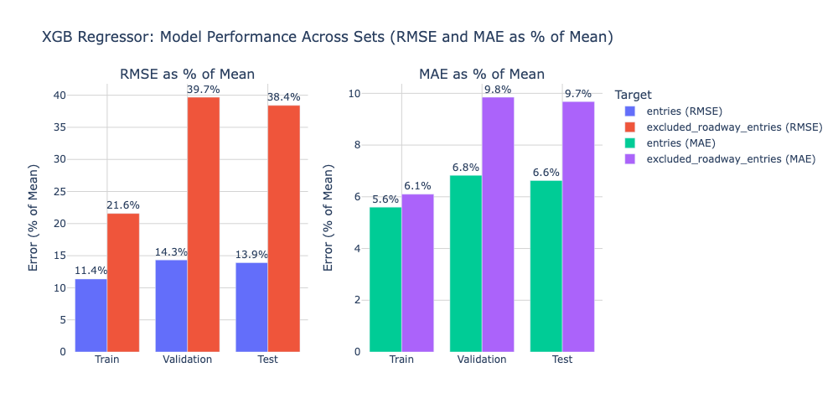
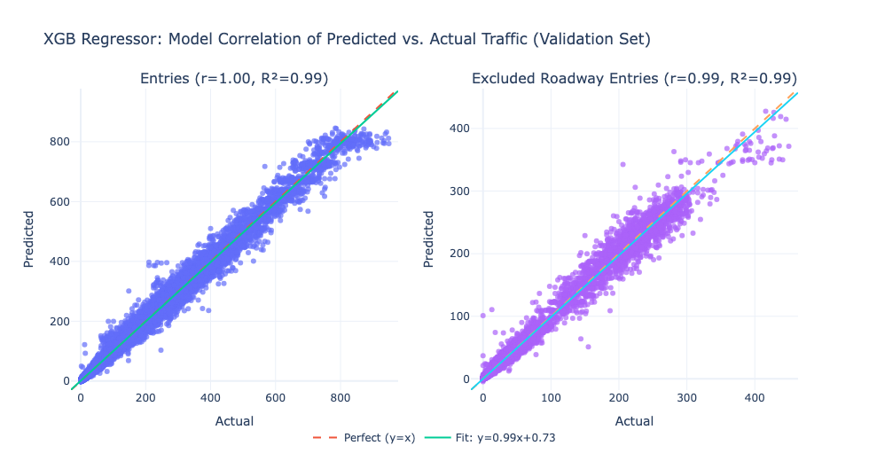
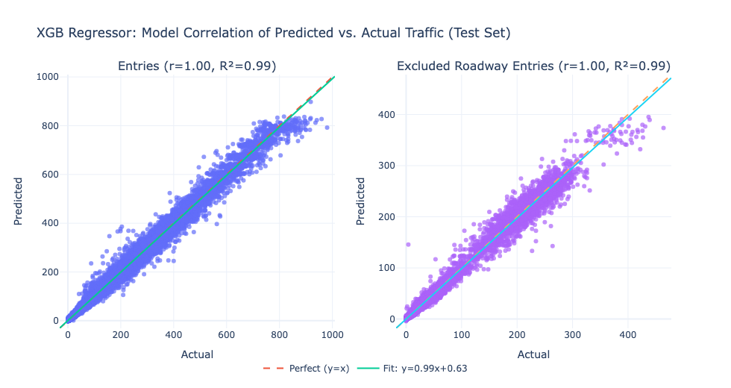
XGB vs. RF: XGBoost outperforms the Random Forest model on the validation and test sets across all metrics and both target variables. The gap is most notable for entries, where XGBoost reduces RMSE by ~3 vehicles and MAE by ~1.5 vehicles, while improving the test set R^2 by ~0.004. For excluded_roadway_entries, the improvement is smaller but still consistent. XGBoost lowers RMSE by ~0.8 vehicles, lowers MAE by ~0.15 vehicles, and increases R^2 by ~0.004. Although these differences are small (<1 to 3 vehicles), they indicate that XGBoost generalizes better and captures the underlying structure of the traffic inflows more accurately than Random forest due to its boosting framework and built-in regularization.
XGBoost also narrows the gap to the original target of RMSE and MAE within 5% of average traffic volume. RMSE decreases to ~14% of the mean for entries and RMSE = 38-40% of the mean for excluded_entries, compared to 17-18% and 46-47%, respectively, under Random Forest. We get much closer to the MAE target for entries, at 6-7% of the mean. For excluded_entries, MAE is reduced to ~10% of the mean from ~11% with Random Forest.
The earlier interpretation regarding the discrepancy in performance for the two targets stands. That is, excluded roadway entries reflect broader regional traffic behavior and introduce decision-making behavior that we cannot capture. Regardless, the error values for both targets are very strong and reinforce the conclusions that (a) the Congestion Zone is a strong candidate for forecasting, and (b) subway patterns can be meaningful to traffic predictions.
Weights: The feature importances for the both targets under the XGBoost model are more skewed toward the relevant rolling means than under the Random Forest model:
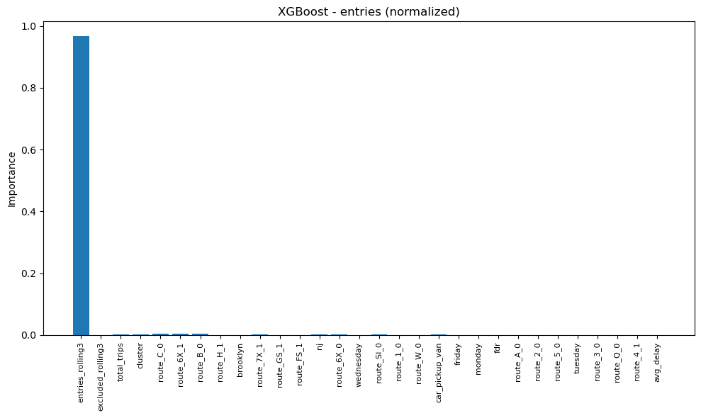
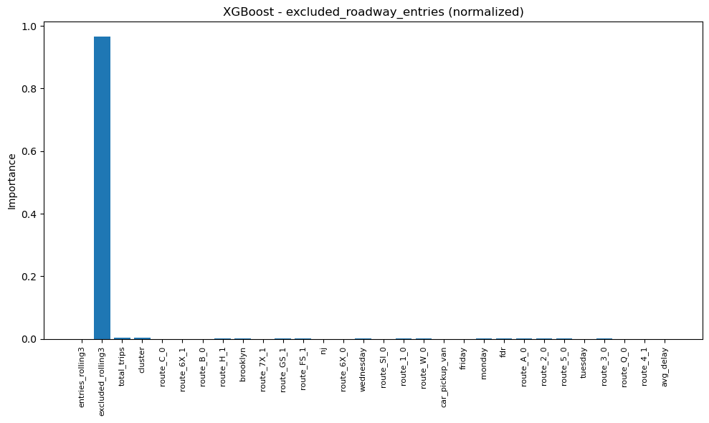
While the rolling means accounted for about 50% of the importance under Random Forest, they constitute >90% of the importance for both target variables under XGBoost. Relative to the remaining features, total subway trips remain important, supporting our second conclusion about the subway-traffic relationship. The cluster labels share the same importance as the total subway trips but are still low in importance overall. Interestingly, a few subway routes take on more importance than specific vehicle classes and roadways. However, these differences are mostly negligible since all the non-rolling features have near-zero importances. This skew likely reflects the model’s boosting mechanism concentrating almost all the predictive weight on the strongest, most stable features, which is naturally the rolling averages here.
(An important note on feature importances: The plotted importances reflect only the top-ranking features again. For the XGBoost model, we used standard variance/impurity-based `model._feature_importances_` and normalized values between 0 and 1 before plotting.)
Time Plots: The XGBoost model does much better at capturing extreme points for entries, but still tends to miss them for excluded_entries, consistent with the generally weaker performance on excluded_entries. The previous recommendations apply here as well: integrating additional external data sources, complementing or substituting clustering with anomaly detection, and/or tweaking the hyperparameters to increase sensitivity to extremes.
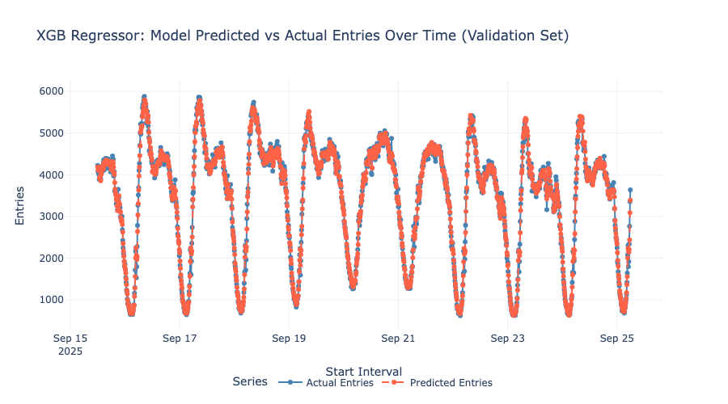
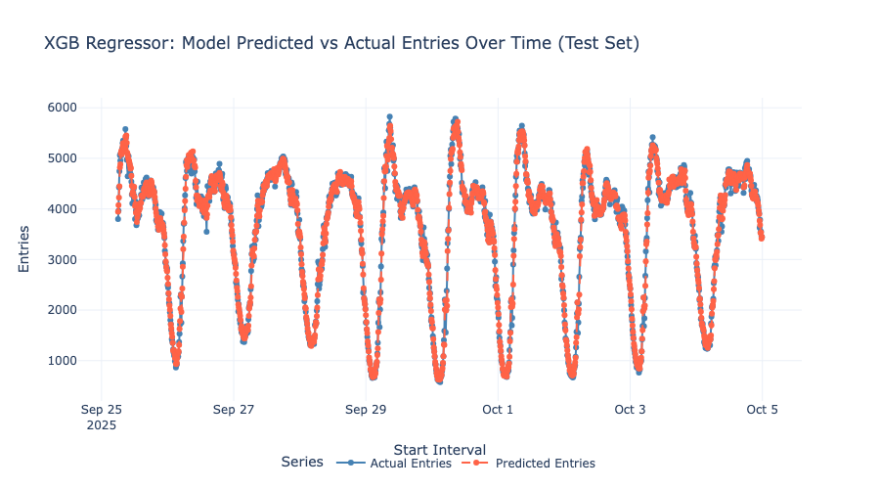
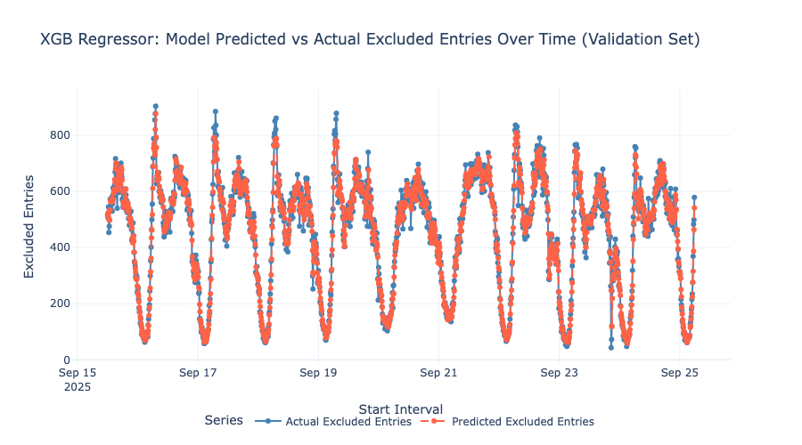
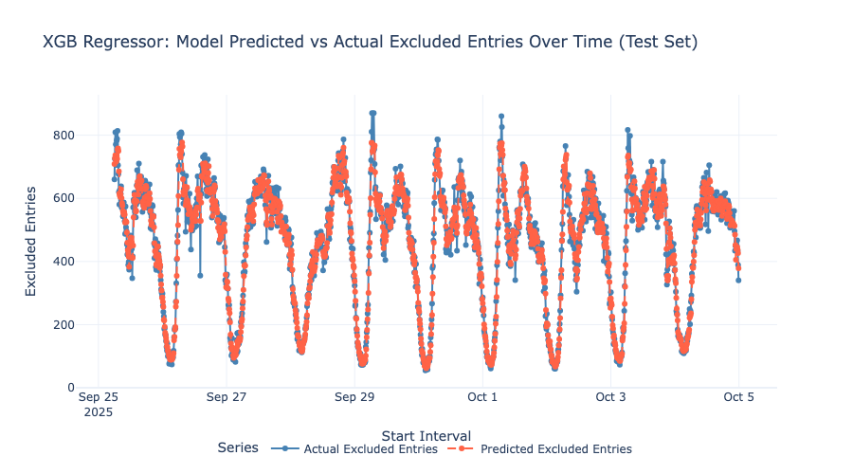

Collaboration:

Gantt Chart:
Google Sheets Link

Contribution Table:
Name | Contributions
Emily Yang | XGBoost Model
Sriathmiha K Bhaskaran | Visualizations
Nimit Sharma | Revised Clustering Model
Sarah Friedrichs | XGBoost Model, Presentation Slides
Anoosha Thumma | Debugging, Report, Presentation Slides

Award Eligibility:
We will be opting into the awards.

References (updated):
[1] P. Miner, B. M. Smith, A. Jani, G. McNeill, and A. Gathorne-Hardy, “Car harm: A global review of automobility’s harm to people and the environment,” Journal of Transport Geography, vol. 115, p. 103817, Feb. 2024, doi: 10.1016/j.jtrangeo.2024.103817.
[2] “Congestion Relief is Unlocking a Better New York,” MTA. https://congestionreliefzone.mta.info/ (accessed Oct. 01, 2025).
[3] “Initial data from Congestion Relief Tolling,” Environment & Health Data Portal. https://a816-dohbesp.nyc.gov/IndicatorPublic/data-stories/congestion-tolling-update/ (accessed Oct. 01, 2025).
[4] Bureau of Policy and Research and S. M. Stringer, “The human cost of subway delays: A survey of New York City riders,” report, Jul. 2017. [Online]. Available: https://comptroller.nyc.gov/wp-content/uploads/documents/The-Human-Cost-of-Subway-Delays.pdf
[5] Y. Li and C. Shahabi, “A brief overview of machine learning methods for short-term traffic forecasting and future directions,” SIGSPATIAL Special, vol. 10, no. 1, pp. 3–9, Jun. 2018, doi: 10.1145/3231541.3231544.
[6] S. Cohen PhD, “The success and challenges of congestion pricing in New York City,” Columbia University School of Professional Studies, Jul. 21, 2025. [Online]. Available: https://sps.columbia.edu/news/success-and-challenges-congestion-pricing-new-york-city
[7] “Time Series Forecasting with Random Forest,” Statworx, Sep. 25, 2019. https://www.statworx.com/en/content-hub/blog/time-series-forecasting-with-random-forest
[8] N. Arya, “Random Forest Regressor,” KD Nuggets, Jul. 25, 2022. https://www.kdnuggets.com/2022/07/random-forest-algorithm-need-normalization.html
[9] “Is it necessary to normalize data for XGBoost?,” Data Science Stack Exchange, https://datascience.stackexchange.com/questions/60950/is-it-necessary-to-normalize-data-for-xgboost (accessed Nov. 29, 2025).
[10] A. Awan, “Understanding dimensionality reduction,” DataCamp, Jan. 21, 2025. https://www.datacamp.com/tutorial/understanding-dimensionality-reduction
[11] “Factor analysis of mixed data,” RPubs, https://rpubs.com/aliro/831890 (accessed Nov. 5, 2025).
[12] T. LaViale, “Understanding HDBSCAN: A Deep Dive into Hierarchical Density-Based Clustering,” Arize AI, https://arize.com/blog-course/understanding-hdbscan-a-deep-dive-into-hierarchical-density-based-clustering/ (accessed Nov. 5, 2025).
[13] M. Ali, “Clustering in Machine Learning: 5 Essential Clustering Algorithms,” DataCamp, Aug. 09, 2022. https://www.datacamp.com/blog/clustering-in-machine-learning-5-essential-clustering-algorithms
[14] A. Bajaj, “Anomaly detection in time series,” neptune.ai, Apr. 24, 2025. https://neptune.ai/blog/anomaly-detection-in-time-series
[15] J. Korstanje, “How to select a model for your Time Series Prediction Task [Guide],” neptune.ai, Apr. 22, 2025. https://neptune.ai/blog/select-model-for-time-series-prediction-task
[16] “1.11. Ensembles: Gradient boosting, random forests, bagging, voting, stacking,” scikit-learn, https://scikit-learn.org/stable/modules/ensemble.html (accessed Nov. 5, 2025).
[17] B. P. C., “Hyperparameter Tuning: GridSearchCV and RandomizedSearchCV, Explained,” KD Nuggets, Nov. 23, 2023. https://www.kdnuggets.com/hyperparameter-tuning-gridsearchcv-and-randomizedsearchcv-explained
[18] “XGBoost for Regression,” Machine Learning Mastery, https://machinelearningmastery.com/xgboost-for-regression/ (accessed Nov. 29, 2025).
[19] A. Singh, “Decoding Distance: Understanding Euclidean and Manhattan Metrics,” Kaggle, https://www.kaggle.com/discussions/general/576329 (accessed Nov. 29, 2025).

